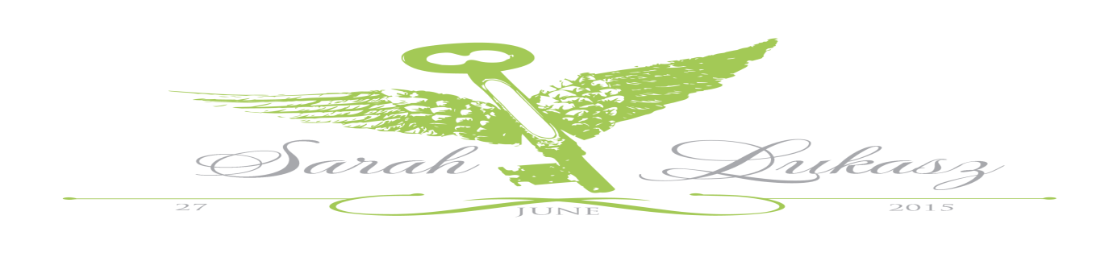

Wedding Breakfast Menu

***Please select on of choice from each of the courses and write your names on back of the menu***

Starter

**Broccoli and stilton soup with a bread roll (V)**

**Tomato and basil soup with a bread roll (V)**

**Cream of mushroom soup with a bread roll (V)**

**Duo of melon with an orange and stem ginger syrup (V)**

**Smoked mackerel pate with Melba toast**

**Garlic mushrooms on toasted ciabatta (V)**

Main Course

**Poached breast of chicken with a Dijon mustard sauce**

**Roast rib of beef with a bordelaise sauce**

**Loin of Oxfordshire pork with an apple and calvados chutney**

**Roasted vegetable lasagne with salad and garlic bread (V)**

**Asparagus and pea risotto with pecorino shavings (V)**

Dessert

**Chocolate fudge cake with fresh cream**

**Raspberry shortcakes with an apricot sauce**

**Sticky toffee pudding with a toffee sauce and custard**

**Lemon tart with fruit coulis**

* * * * *

**Tea/Coffee and chocolate mints**

**All main courses include one serving of vegetables and potatoes, All dishes marked (V) are suitable for vegetarians**



Children’s Menu

***Please select on of choice from each of the courses and write your names on back of the menu***

Starter

**Homemade cream of tomato soup with bread roll**

**Garlic bread with cheese topping**

**Chilled Melon**

Main Course

**Margarita Pizza with fries**

**Homemade chicken nuggets or fish finger with fries and peas**

**Penne pasta with tomato sauce topped with cheese**

Dessert

**Ice cream with chocolate and strawberry sauce**

**Fruit salad with ice cream or cream**

* * * * *